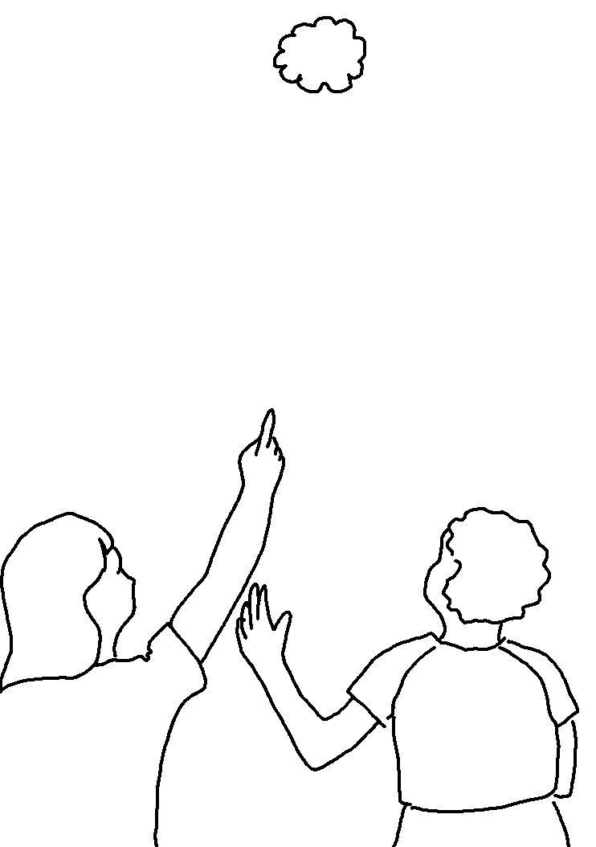
This is our God; we have waited for Him, and
He will save us. Isaiah 25:9_{NKJV}

